

GROUB ASSIGNMENT (PART2)
TECHNOLOGY PARK MALAYSIA.
Introduction To Database.
HAND OUT DATE: 14 APRIL.
HAND IN DATE: 22 JUN.
WEIGHTAGE: 60%.
NO | NAME | TP NUMBER
1 | Mouhamad Abdoul Hamid Siby (Leader) | TP088360
2 | Chan Hua Shean | TP088650
3 | Mohamed Aliou Cherif Diallo | TP084848
4 | Mohammed Waled Mohammed Bin Mahmood | TP087567
5 | Sohel | TP079625

Table of Contents
Part-2 – Implementation (60%) 2
4. Database Schema. 2
4.1. Entity Relationship Diagram (ERD) 2
4.2. Database Schema 3
5 SQL- Data Definition Language (DDL). 3
5.1 Database Dictionary 3
5.2. Creating and Inserting Database & Tables 8
5.2.1 Database Creation and Table Structure 8
5.2.2. Inserting Data into the Tables 9
6. SQL – Data Manipulation Language (DML) 15
1) Write an SQL query to find customers who placed orders with a total amount greater than $50. Sort the list by descending order 15
2) Write an SQL query to find all orders placed between '2023-10-01' and '2023-10-31' with a delivery status of "Delivered". 15
3) Write an SQL query to find the minimum order value for each customer. 15
4) Write an SQL query to find all menu items ordered by a customer named "Sarah". 16
5) Write an SQL query to find the average rating given to each restaurant. 16
6) Write an SQL query to find customers who ordered "Hawaiian Pizza". 17
7) Write an SQL query to calculate the total revenue generated from deliveries handled by each delivery person. 17
8) Write an SQL query to find the top-selling menu item (the item ordered the most). 18
9) Write an SQL query to find customers who placed orders in October 2024. 18
10) Write an SQL query to find customers who have not placed any orders. 19
11) List all orders with customer names and restaurant addresses. Only show records where the customer and restaurant exist. 20
12) Display all deliveries, including those without assigned delivery personnel, showing the customer name and delivery person. 21
13) Find customers who gave a 5-star rating, and match with the restaurant and delivery person reviewed. 22
14) Show all delivery personnel and the total orders they handled, including those with zero deliveries. 23
15) Show all customers with their total spending. Include customers who haven't placed any orders. 24

Part-2 – Implementation (60%)

4. Database Schema.

4.1. Entity Relationship Diagram (ERD)
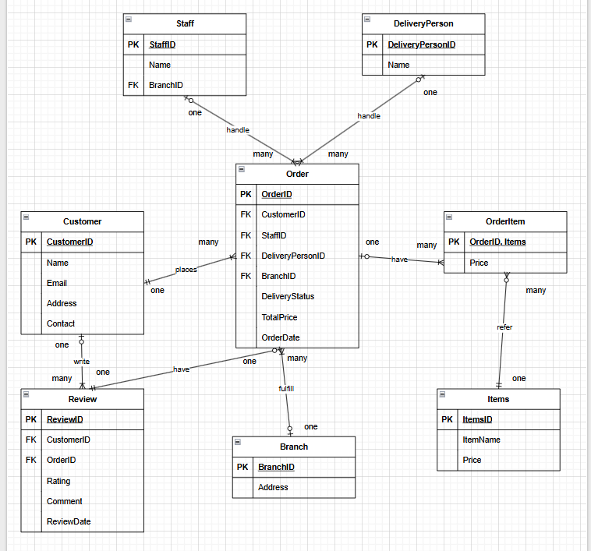

4.2. Database Schema
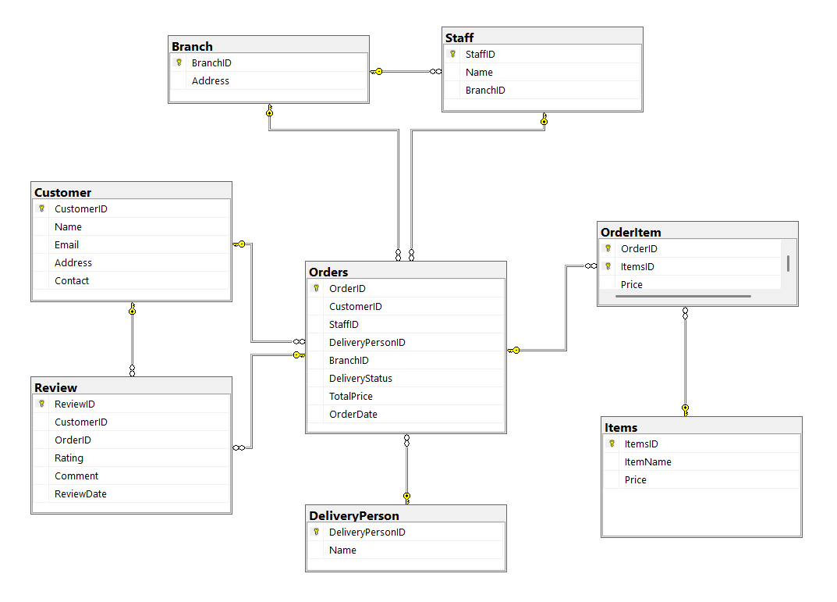

5 SQL- Data Definition Language (DDL).

5.1 Database Dictionary
For database creation, we developed 8 tables based on our 3NF-normalized design in Part 1B. These tables include:
- Branch
- Staff
- DeliveryPerson
- Customer
- Items
- Orders
- OrderItem
- Review
Based on the anticipated nature of the data, we allocated data types and character restrictions. To guarantee proper representation of monetary quantities, for example, the decimal(10,2) data type is used in the Price attributes of the Items and OrderItem tables. Similar to this, fields such as Name, Email, and Address are equipped with character limitations (such as nvarchar(50) or nvarchar(100)) that are adequate to accommodate a variety of user inputs without truncating them.
Another illustration might be the OrderDate and ReviewDate characteristics, which are formatted and saved as DATE to monitor order timings and feedback. Enabling sorting, filtering, and analytics over time depends on this.
Regarding the main limitations:
- Its primary key uniquely identifies each row in a table. For instance, CustomerID in the Customer table and OrderID in the Orders table.
- Referential integrity between connected tables is enforced using foreign keys. To guarantee that every order is allocated to a legitimate employee, the StaffID in the Orders database, for instance, is a foreign key referencing Staff(StaffID).
- To uniquely identify each item inside an order, we used OrderID and ItemsID to create composite primary keys in the OrderItem database.
This dictionary ensures that the database schema is logical, normalized, and supports the applications data management needs effectively.
Branch
Branch table contains the following data:
(BranchID, Address)
Primary Key: BranchID
Alternate Keys: NULL
Foreign Keys: NULL
Attribute | Description | Data Type and Length
BranchID | A unique identifier for the branch. | National variable character (50)
Address | The physical location/address of the branch. | National variable character (50)

Staff
Staff table contains the following data:
(StaffID, Name, BranchID)
Primary Key: StaffID
Alternate Keys: NULL
Foreign Key: BranchID → Branch(BranchID)
Attribute | Description | Data Type and Length
StaffID | A unique identifier for each staff member. | National variable character (50)
Name | The name of the staff member. | National variable character (50)
BranchID | Identifies the branch the staff works at. | National variable character (50)

DeliveryPerson
DeliveryPerson table contains the following data:
(DeliveryPersonID, Name)
Primary Key: DeliveryPersonID
Alternate Keys: NULL
Foreign Keys: NULL
Attribute | Description | Data Type and Length
DeliveryPersonID | A unique ID for each delivery person. | National variable character (50)
Name | The name of the delivery person. | National variable character (50)

Customer
Customer table contains the following data:
(CustomerID, Name, Email, Address, Contact)
Primary Key: CustomerID
Alternate Keys: NULL
Foreign Keys: NULL
Attribute | Description | Data Type and Length
CustomerID | A unique ID to identify each customer. | National variable character (50)
Name | Customer’s full name. | National variable character (50)
Email | Email address of the customer. | National variable character (50)
Address | The delivery address of the customer. | National variable character (50)
Contact | Phone number or contact info of the customer. | National variable character (50)
Items
Items table contains the following data:
(ItemsID, ItemName, Price)
Primary Key: ItemsID
Alternate Keys: NULL
Foreign Keys: NULL
Attribute | Description | Data Type and Length
ItemsID | A unique ID to identify each menu item. | National variable character (50)
ItemName | Name of the food item (e.g., Garlic Bread). | National variable character (100)
Price | Price of the item. | Decimal (10,2)

Orders
Orders table contains the following data:
(OrderID, CustomerID, StaffID, DeliveryPersonID, BranchID, DeliveryStatus, TotalPrice, OrderDate)
Primary Key: OrderID
Alternate Keys: NULL
Foreign Keys:
CustomerID → Customer(CustomerID)
StaffID → Staff(StaffID)
DeliveryPersonID → DeliveryPerson(DeliveryPersonID)
BranchID → Branch(BranchID)
Attribute | Description | Data Type and Length
OrderID | Unique identifier for each order. | National variable character (50)
CustomerID | Identifies the customer who placed the order. | National variable character (50)
StaffID | Staff who processed the order. | National variable character (50)
DeliveryPersonID | Delivery person assigned to deliver the order. | National variable character (50)
BranchID | Branch from where the order originated. | Variable character (50)
DeliveryStatus | Current delivery status (e.g., Out for Delivery). | Variable character (50)
TotalPrice | Total price of the order. | Decimal (10,2)
OrderDate | Date when the order was placed. | Date

OrderItem
OrderItem table contains the following data:
(OrderID, ItemsID, Price)
Primary Key: (OrderID, ItemsID)
Foreign Keys:
OrderID → Orders(OrderID)
ItemsID → Items(ItemsID)
Attribute | Description | Data Type and Length
OrderID | The ID of the order containing the item. | National variable character (50)
ItemsID | The ID of the item in the order. | National variable character (50)
Price | Price of the item at time of order. | Decimal (10,2)

Review
Review table contains the following data:
(ReviewID, CustomerID, OrderID, Rating, Comment, ReviewDate)
Primary Key: ReviewID
Foreign Keys:
CustomerID → Customer(CustomerID)
OrderID → Orders(OrderID)
Attribute | Description | Data Type and Length
ReviewID | Unique identifier for the review. | National variable character (50)
CustomerID | Customer who wrote the review. | National variable character (50)
OrderID | Order for which the review is given. | National variable character (50)
Rating | Numeric rating provided (e.g., 1–5). | Integer
Comment | Textual feedback or remarks. | National variable character (100)
ReviewDate | Date when the review was submitted. | Date

5.2. Creating and Inserting Database & Tables
To build the database for the Delicious Pizza system, we followed a structured approach based on our normalized 3NF design. The process began with the creation of the database itself, followed by switching into that database context to ensure that all tables and data would be correctly associated with it.

5.2.1 Database Creation and Table Structure
We developed a total of 8 tables to represent all key entities and their relationships within the Delicious Pizza ordering and delivery application. These tables include:
- Branch
- StaffDeliveryPerson
- Customer
- Items
- Orders
- OrderItem
- Review
Each table's structure was thoughtfully created to accommodate the anticipated volume and kind of data. For instance, to account for variances in real-world data, fields like customer contact, item names, and addresses were given sufficient character limitations (e.g., 50 to 100 characters). To properly handle currency values, price-related variables were specified with numeric accuracy. To enable sorting, filtering, and analysis across time, dates like order and review dates were saved using the proper date formats.
A primary key is included in every table to guarantee uniqueness and facilitate trustworthy reference. To ensure referential integrity between tables, foreign key connections were created when needed. For instance, these relationships may link customers to their orders or orders to the relevant staff and delivery workers.
The database structure mirrors actual business logic, including:
- Although a single client is linked to a single order, each customer may place several orders.
- One employee and one delivery person handle order fulfilment.
- Multiple things may be included in each order, and the same item may be included in more than one order.
- Consumers who have received orders can leave evaluations.
All of these connections were created using the guidelines provided in our earlier 3NF normalization processes, and foreign keys enforce them all.

5.2.2. Inserting Data into the Tables
After the tables were created, sample data was inserted to represent real-world usage. The dataset includes records for various entities:
- Multiple customers with unique IDs, contact details, and addresses.
- Branches of the restaurant located across different areas.
- Staff and delivery personnel assigned to those branches.
- Menu items with names and prices.
- Orders made by customers, with total prices and order statuses.
- Items within each order, showing the breakdown of what was purchased.
- Customer reviews, including ratings and comments for completed orders.
The relevant and consistent data in each table represents the normal functioning of the pizza ordering and delivery system. As an illustration, one of the clients made an order with several things, which a staff member prepared and a delivery person brought. The review table was updated with the customer's rating and feedback upon delivery.
We retrieved and examined the database contents using conventional SQL queries to confirm the data insertion and structure. This verified that all formatting rules, restrictions, and data relationships were operating as intended.
The 3NF standards were followed in the construction and populating of every table, guaranteeing high data integrity, reduced redundancy, and effective data access across the system.
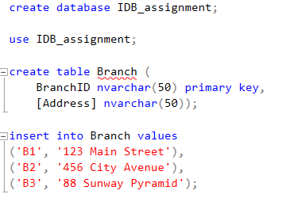
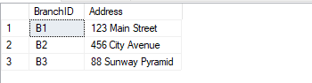
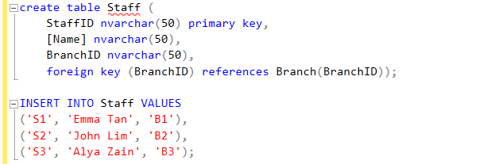
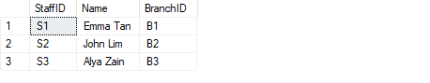
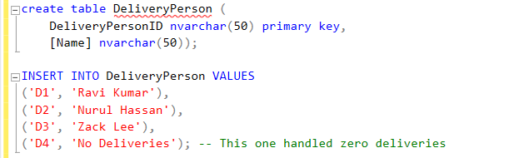
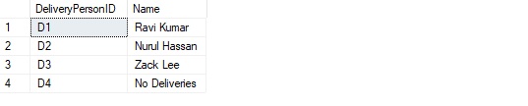
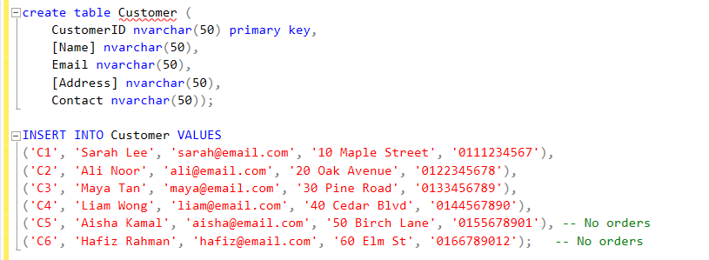
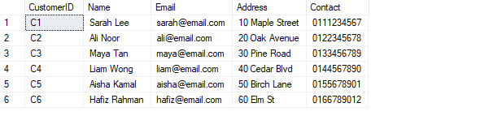
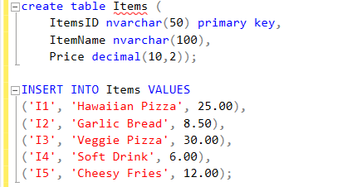
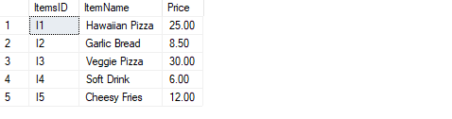
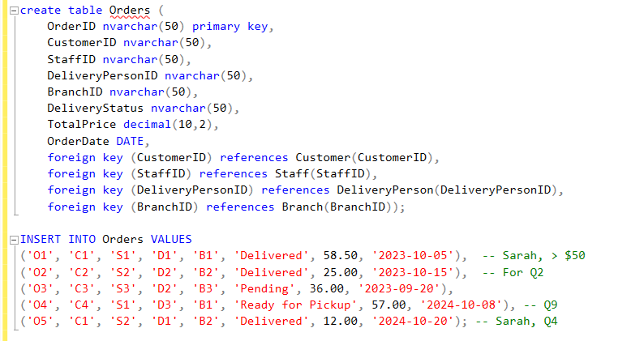
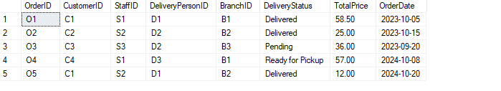
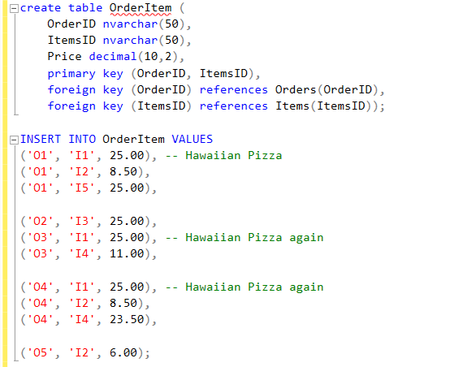
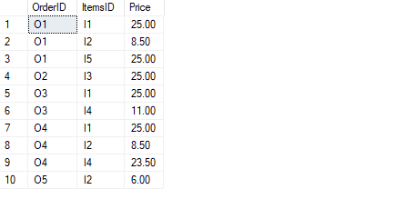
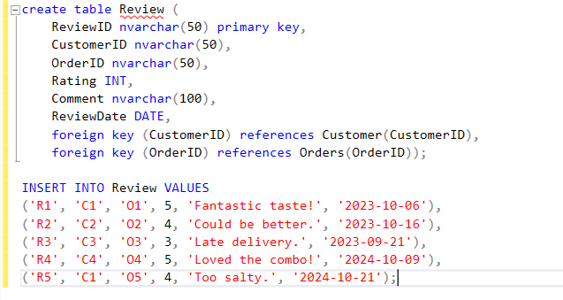
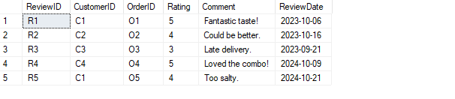

6. SQL – Data Manipulation Language (DML)

1) Write an SQL query to find customers who placed orders with a total amount greater than $50. Sort the list by descending order
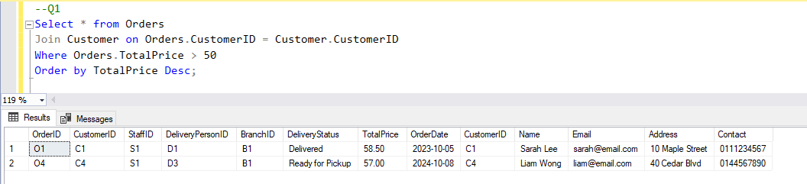
Retrieving every order with a total price over $50 in order to detect high-value transactions. In order to display order and customer information, it connects the Orders and Customer databases. The results are then arranged in decreasing order of total price. Management might use this to keep track of important clients or big orders.

2) Write an SQL query to find all orders placed between '2023-10-01' and '2023-10-31' with a delivery status of "Delivered".
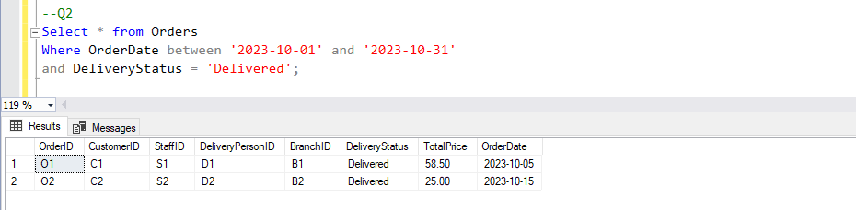
Filters orders that were successfully delivered in October 2023. This query is helpful for examining order performance over particular times, such monthly sales or delivery completion rates, by utilizing date ranges and status criteria.

3) Write an SQL query to find the minimum order value for each customer.
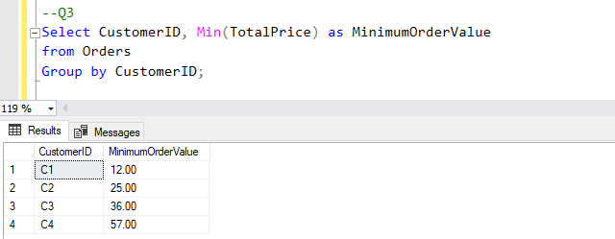
Uses aggregation to determine each customer's minimum order value. Understanding specific consumer behavior, such the lowest amount they have ever spent on a single purchase, is helpful for marketing or loyalty analytics.

4) Write an SQL query to find all menu items ordered by a customer named "Sarah".
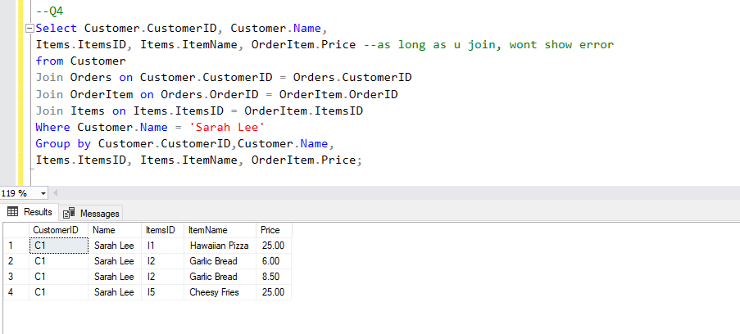
Returns a list of the products that a certain client, "Sarah Lee," has bought, along with a breakdown of her orders that includes item names and pricing. In order to accommodate numerous entries per customer, this necessitates combining many tables: Customer, Orders, OrderItem, and Items. The results must then be grouped.

5) Write an SQL query to find the average rating given to each restaurant.
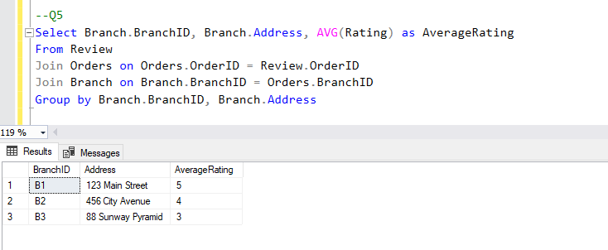
Determines each restaurant branch's average customer review rating. To link feedback to branch locations, it employs aggregation and joins across the Review, Orders, and Branch databases. This gives information on which branches are doing the best in terms of client satisfaction.

6) Write an SQL query to find customers who ordered "Hawaiian Pizza".
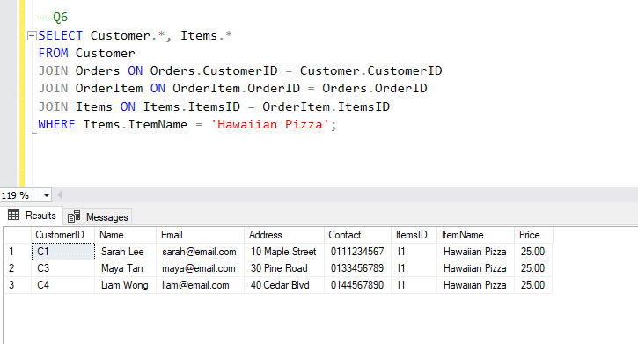
Locates every consumer who has placed an order for the particular item, "Hawaiian Pizza." This facilitates client segmentation according to product preferences and item-level popularity analysis.

7) Write an SQL query to calculate the total revenue generated from deliveries handled by each delivery person.
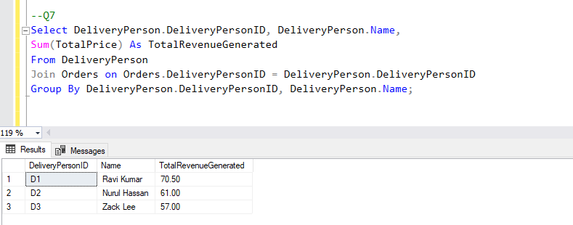
Enumerates the total amount of money made by every delivery worker. It offers helpful performance data that may be used to assess and compensate delivery staff according to their sales contribution by combining the Orders and DeliveryPerson tables.

8) Write an SQL query to find the top-selling menu item (the item ordered the most).
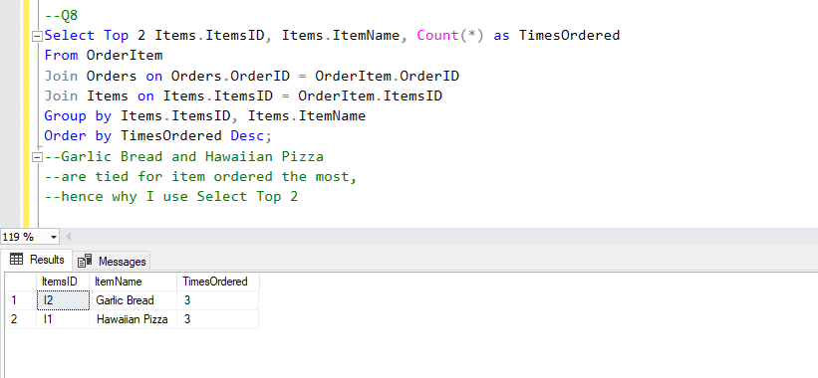
Indicates the two menu items that are most often requested. It facilitates inventory planning and identifies client favorites, which can inform promotional efforts, by narrowing the result set and counting item occurrences.

9) Write an SQL query to find customers who placed orders in October 2024.
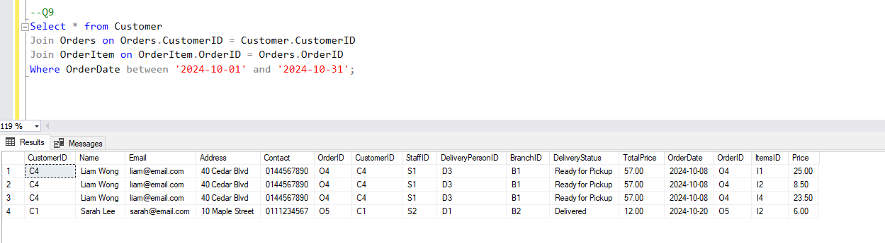
Provides a thorough summary of client activity during that time by retrieving detailed order data for October 2024 and combining them with client, Orders, and OrderItem. Reporting and performance analysis at the end of the month benefit from it.

10) Write an SQL query to find customers who have not placed any orders.
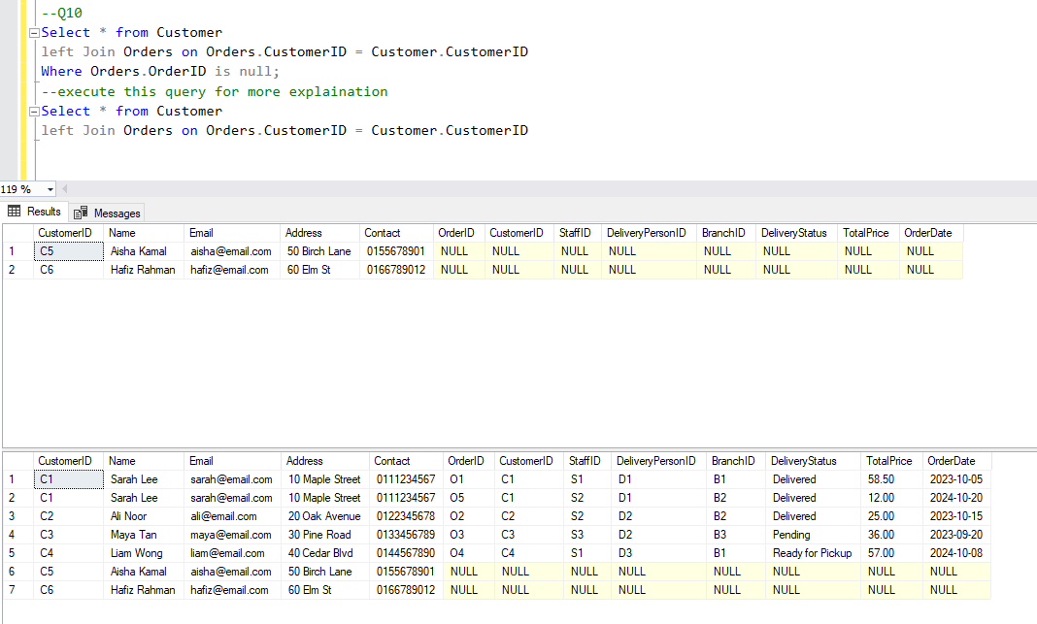
Uses an LEFT JOIN and filtering where OrderID is nil to identify consumers who have not placed any orders. This makes it easier to find idle users, which is useful for focused re-engagement efforts.

11) List all orders with customer names and restaurant addresses. Only show records where the customer and restaurant exist.
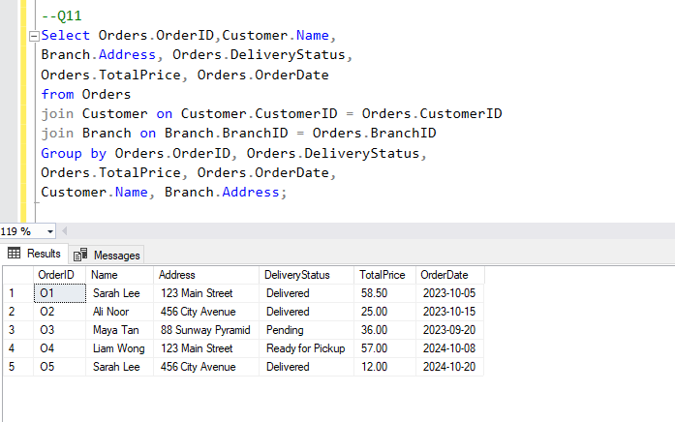
Shows an order summary that includes information on the client, branch, order date, total cost, and delivery status. It supports delivery reporting and transaction-level tracking by combining and grouping data from related tables.

12) Display all deliveries, including those without assigned delivery personnel, showing the customer name and delivery person.
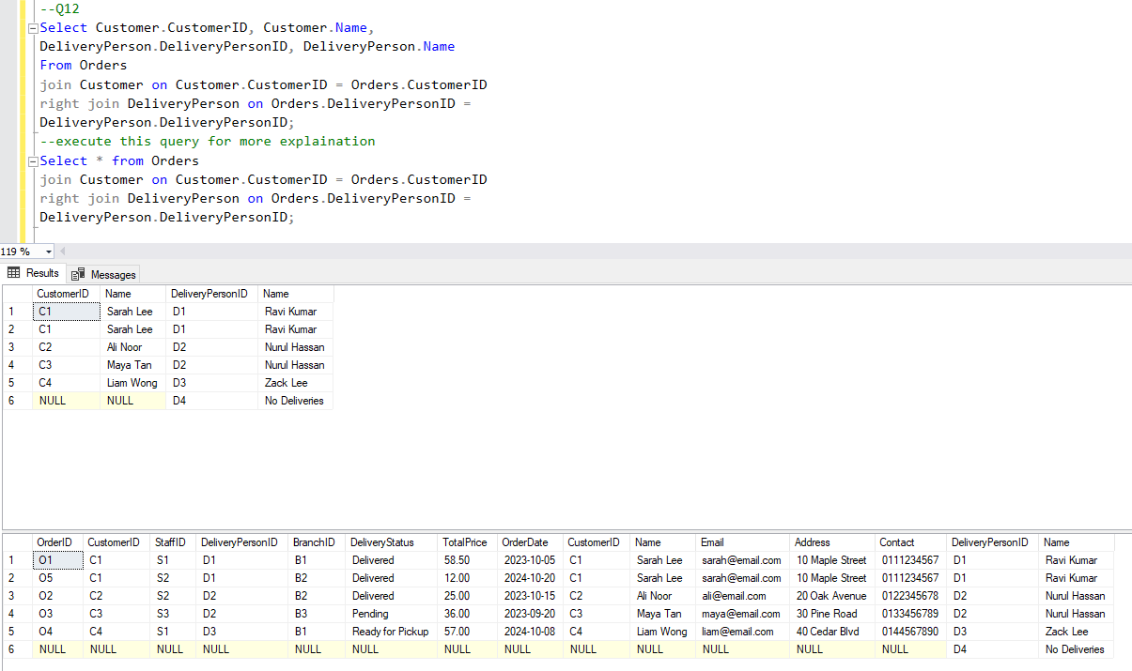
Includes all delivery staff, including those who might not have any orders allocated to them at the moment, by combining customer and delivery person data using a RIGHT JOIN. This can assist in identifying underutilized employees or ensuring an equitable workload distribution.

13) Find customers who gave a 5-star rating, and match with the restaurant and delivery person reviewed.
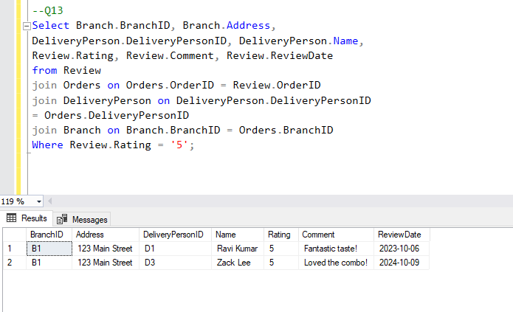
Enables you to evaluate high-performing teams or locations based on customer satisfaction by listing all 5-star ratings along with the related delivery person and branch.

14) Show all delivery personnel and the total orders they handled, including those with zero deliveries.
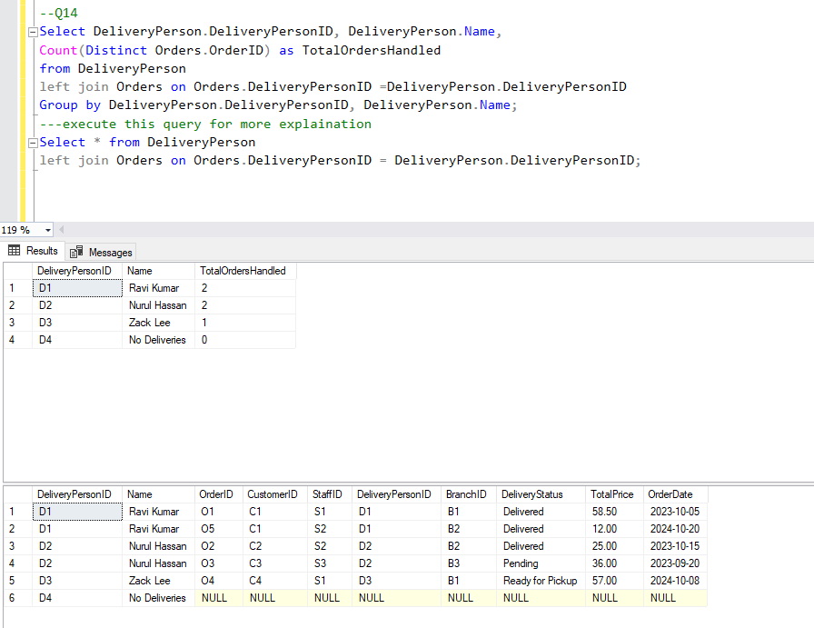
Use an LEFT JOIN to determine how many orders each delivery worker has handled. This gives management a comprehensive picture of the performance and assignments of delivery crew, even those who may not have handled any orders.

15) Show all customers with their total spending. Include customers who haven't placed any orders.
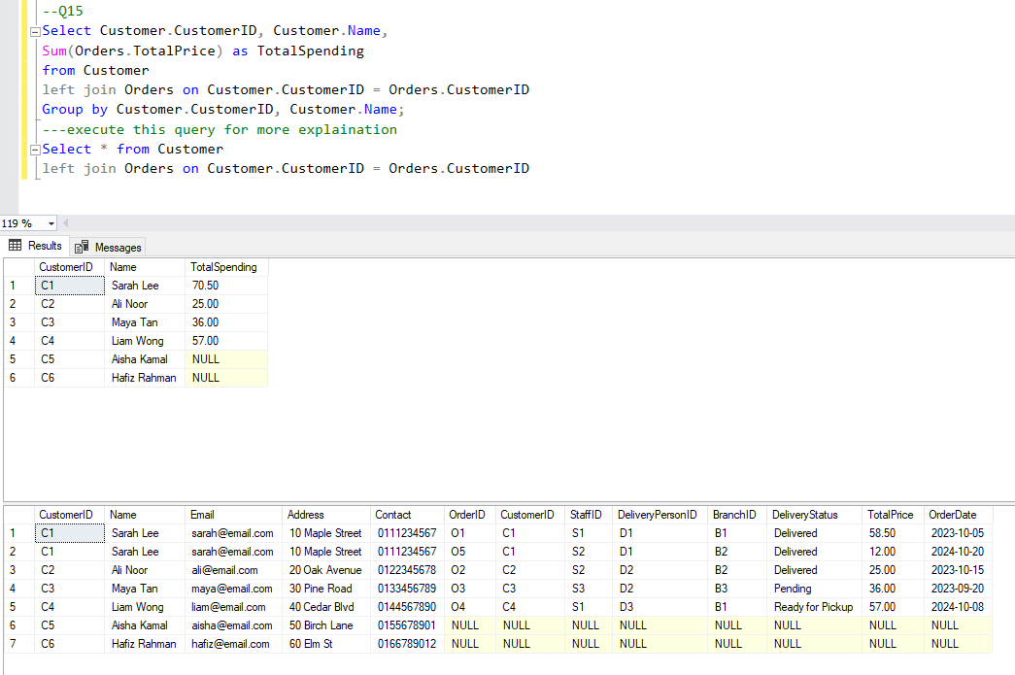
Sums up each customer's order totals to determine how much they have spent overall. This enables the company to divide up its most expensive clients into groups for loyalty plans or focused advertising.

